Network-Based Cyber Risk and Resilience Assessment of the MBTA Payment System Using MBRA and Graph-Theoretic Metrics

Release Date: 12/03/2025
Memorandum For: Secretary of DHS or Secretary of Sector Specific Agency.
From: Mihir Soman

Network-Based Cyber Risk and Resilience Assessment of the MBTA Payment System Using MBRA and Graph-Theoretic Metrics

Release Date: 12/03/2025
Memorandum For: Secretary of DHS or Secretary of Sector Specific Agency.
From: Mihir Soman

Table of contents:
Introduction…………………………………………………………………………………………………3
1.1 Overview of Smart Transportation Systems………………………………………………………….3
1.2 Importance of MBTA AFC 2.0 as a CIKR Network………………………………………………….3
1.3 Research Questions and Objectives…………………………………………………….………….…4
Background and Literature Review………………………………………………………………………....4
2.1 Cyber-Physical Systems in Transportation…………………………………………………….….….4
2.2 Critical Infrastructure and Interdependency Concepts……………………………………………….4
2.3 Related Attacks on Fare Systems Globally...........................................................................................5
Overview of the MBTA AFC 2.0 Architecture...............................................................................................5
3.1 System Components and Data Flow....................................................................................................5
3.2 Key Nodes and Subsystems for Risk Modeling...................................................................................6
3.3 Mapping the Payment-Flow Network..................................................................................................6
Threat Landscape and Potential Cyberattack.................................................................................................6
4.1 Threats to AFC 2.0 Network Components...........................................................................................7
4.2 Cascading Impact of targeted attacks on Node....................................................................................7
Network Characterization and Modeling Metrics..........................................................................................7
5.1 Node List and Adjacency Structure and Spectral Radius.....................................................................7
5.2 Centrality Analysis (Degree / Betweenness) .......................................................................................9
5.3 Robustness and Blocking Nodes and Resilience Line.........................................................................9
MBRA Risk Assessment Framework...........................................................................................................10
6.1 Methodology and Budgeting Assumptions.........................................................................................10
6.2 Hazard Categorization and Dependencies..........................................................................................10
6.3 Example scenarios of adversarial Random attacks..............................................................................11
6.4] Cascading Impacts on other nodes.....................................................................................................11
Findings from the Cascading Model.............................................................................................................12
7.1 Budget Sensitivity and Risk Reduction Insights.................................................................................12
7.2 Fault Tree Analysis Results.................................................................................................................13
7.3 Non-Intuitive Insights from the Model...............................................................................................13
Discussion....................................................................................................................................................14
8.1 Required Budget for Mitigation and Resilience.................................................................................14
Discussion of Cyber Workforce…………...................................................................................................15
Potential Cyberattacks……………………………………………………………………………….…….15
Mitigation and Resilience Strategies............................................................................................................16
10.1 Technical Security Controls..............................................................................................................16
10.2 Operational Security Controls..........................................................................................................16
10.3 Governance and Compliance Recommendations.............................................................................17
ROI and Funding Opportunities...................................................................................................................17

Limitations and Future Improvements..........................................................................................................18

Conclusion and Future Work........................................................................................................................18

References....................................................................................................................................................20

Appendices...................................................................................................................................................22
A. Network Graphs and Simulation Charts
B. Fault-Tree Diagrams
C. Calculation Tables

1] Introduction:
1.1] Overview of smart transportation systems
Critical infrastructure assets have a life-changing impact on our day-to-day lifestyle. Modern societies rely heavily on CIKR assets, and these assets are of high importance to soother human life, sustain economy, mobility and public safety in adverse conditions. Among the CIKR assets everyone uses the transportation sector daily. It helps in fast mobility and transportation of goods and services. It plays a vital role in urban economy and increasing network of vehicles has resulted in the adoption of various Information Technology domains in transportation sector. Today’s transportation is data driven and is highly interconnected with networks and other CIKR domains. One such sector in which transportation has made tremendous progress is the fare collection system. The new digitalized fare collection systems are smoother, faster and can be backtracked if anything happens. Consequently, depending upon digital assets for fare collection means involving many digital assets like servers, machines, data and mainly a network of these devices. Digitalized devices follow cybersecurity threats and considering the widespread and importance of CIKR structure these can have catastrophic effects on public life.
One such major transportation example observed with digitalized transformation is the Massachusetts Bay Transportation Authority (MBTA), which manages Boston’s multi-modal transport network including subway, bus, commuter rail, trolley, and ferry services. The MBTAs network has made a difference in transportation as it provides a wide connection throughout Boston. The MBTAs Commuter rail is approximately 429 miles of track, subway system for 110 miles including 153 stations, and bus network which is estimated to be covering 500 plus miles including bus, electric and hybrid models. In 2018 MBTA with the partnership of Cubic transportation Systems OpCo LLC and John Laing Group [1] initiated Automated Fare Collection 2.0 project called AFC 2.0. The project aimed at replacing the Charliecard system and CharlieTicket systems with modern fare payment systems consisting of contactless, account based, web-based architecture. The new AFC 2.0 system enables passengers to pay fares with multiple modes using contactless cards, mobile wallets and digitalized accounts in every MBTA transportation mode. This fare payment system has modernized the way users would pay, improved user experience and fare flexibility, yet simultaneously introduces cyber threats and vulnerabilities with the network and devices. The MBTAs AFC 2.0 from a very critical cyber-financial infrastructure network integrating thousands of devices (validators, kiosks and gates) with some centralized data bases and aggregators also encompass technologies like cloud and external banking institutions. If a malicious intrusion takes place on the dependent nodes network it can propagate across multiple devices leading to service interruptions, revenue loss or data compromise. Despite the system’s criticality very limited research can be seen done on system resilience and cascading risk behavior if the network is stressed under cyberattack. This paper applies Model Based Risk Assessment (MBRA) framework to MBTAs AFC 2.0 payment network evaluate how components failures or cyber incidents might propagate through interdependent system of devices and their corresponding impacts. The study models the cascade network for the payment AFC 2.0 financial system representing data movement and risk propagation because of effects of cyberattack.
1.2] Importance of MBTA AFC 2.0 as a CIKR Network
MBTAs Transit systems are used by hundreds of thousands of riders daily. It’s an essential urban commodity facilitating fast mobility covering a wide area of Boston, MA. This efficient transportation system is enhanced by integrating with the AFC 2.0 comprising of various technologies making the payment system convenient for the passengers. The AFC 2.0 systems make use of digital tickets, mobile apps, backend cloud and data bases, station hardware and third-party vendors to provide the network for seamless transition experience. However, this transition also renders the network vulnerable to cyberattacks as multiple attack surfaces are opened and hence many attack surfaces can be analyzed. This system is perfect from cybersecurity standpoint of view as this is an example of a rich technological complex cyber-Physical system. A cascading effect may occur if important components from this network is forced shutdown or come under cyberattack. Especially the payment and transport network which encompasses the payment flow within the MBTA AFC 2.0 network. The network is tightly coupled with revenue cycles and operations, and one node failure can cause failures across a larger network.

1.3] Research questions and objectives
Hence, short research can be done specifically targeting the payment flow network of MBTA AFC 2.0, taking into consideration the following points which also represent the objectives of this research paper.
- To analyze architecture, network components, and data flow in MBTA AFC 2.0 system, and identifying its critical nodes.
- To evaluate key cybersecurity threats, vulnerabilities faced by the system, and realistic attack scenarios affecting AFC. 2.0, including operational and payment level risks.
- To examine how disruptions at critical nodes (eg. payment gateways, mobile apps, settlement servers) can produce cascading effects causing operational and financial failures.
- To apply Model-Based Risk Analysis (MBRA) to simulate attacks causing cascading effects quantifying the potential impacts of attacks on AFC 2.0 operations.
- To propose targeted, practical recommendations for improving the resilience, security, and reliability of the AFC 2.0 system within the selected smart transportation ecosystem for MBRA.
2] Background and Literature Review
2.1] Cyber-Physical Systems in transportation
The term Cyber-Physical Systems (CPS) has an importance when studying complex CIKR networks, especially related to transportation. CPS means integration of computation and physical process. Embedded computers and networks monitor and control the physical process, usually with feedback loops where physical processes affect computations and vice versa. From operational point of view, the CPS has helped monitoring the condition of lineside buildings, masonry constructions, drainage systems and signaling systems and tracks. [9] Transportation industry also uses CPS to handle day-to-day activities, making Transportation CPS (TCSP) critical to the safety, security of environment as well as the well-being of the people using the transportation systems. The transportation systems of aviation, rail, and marines make use of TCSP primarily mange it components for passengers and goods. In rail transportation the TCSP is used mainly for detecting the real time rail speed and transmitting the actual speed to the control beacon called Train guard. The signal is meant for the driver to react and decelerates the speed of the train and if the driver fails to respond the signal is passed to actuators and the deacceleration happens. The TCSP is also used for real-time GPS monitoring by monitoring real time train runs and providing customers with accurate timetables via websites, mobile apps and station announcements, thus helping passengers to take smart timely decisions. With advances in technology comes its threats as well. The overlap of number of domains in the CPS systems increased the criticality of the components used and forced industry to think of different approaches to protect data, people and infrastructure against emerging threats.
2.2] Critical Infrastructure and interdependency concepts
Critical infrastructure (CI) refers to process, systems, networks and related tools, software, assets and networks which are essential to public health, safety, security, economy and effective functioning of private and governmental sectors. [8] The CIKR is highly interdependent and primary classes of interdependence are physical and cyber interdependence. The cyber interdependencies arris from the information exchange, usage of networks for automation of tasks and modernizing the infrastructure through computerization and widespread use of supervisory control and data acquisition systems (SCADA).
Transportation industry falls under Critical Infrastructure industry as well and is supported by a array of networks, people, assets, functions and information collection and exchange. Transportation sector is also deeply interconnected with other CIKR sectors like financial sector and the two sectors are bidirectionally dependent shaping operational stability, revenue flow and long-term infrastructure development. Modern transit systems like MBRA rely upon complex financial networks payment mechanisms which supports its daily operations and transportation performance directly affects the financial markets through economic productivity, workforce mobility, and supply chain efficiency. Any disruption in financial services or network used by transportation can immediately impact transit agencies revenue systems and operational continuity. Conversely, major outages in transportation industry can have direct effects on financial markets or lead to economic losses. This interdependency and tight coupling highlight the critical importance of securing both the transportation and its associated financial systems.
2.3] Related attacks on fare systems globally
Globally, cyberattacks have known being targeting public transit systems and services because of exposed vulnerabilities, sensitive data and have revealed attack vector utilizing smart ticket infrastructure for executing the service disruption of data theft. For example, the cyber incident which happened on Trasport for London (TFL), UK. An unconfirmed identity on September 10, 2024, made use of Oyster and contactless payment schemes to gain unauthorized access to systems containing customer data and personal information. The attack vector follows a path comprising of third-party IT systems used by TFL moving laterally till accessing legacy database containing customer information. This affected millions of Londoners including older adults, veterans, and individuals with disability. A similar event in UK rail network took place where 19 U railway stations Wi-Fi services were disrupted and cyber vandalism took place.[6] [7]
3] Overview of the MBTA AFC 2.0 Architecture
3.1] System Components and Data Flow
The MBTA’s AFC 2.0 program represents a large-scale modernization of the agency’s fare collection ecosystem, integrating multiple payment channels—from vehicle-mounted fare boxes and contactless validators to mobile applications capable of reloading CharlieCards and providing trip planning functions. Across buses, subway stations, commuter rail, trolleys, and ferry terminals, the system relies on a wide array of physical devices that serve as the first point of interaction with passengers. To support this extensive infrastructure, MBTA has partnered with OpCo LLC to manage the backend platform responsible for processing fare transactions, account data, and system-wide operational logic.
The transaction flow begins when a passenger taps a contactless card or mobile device on a validator installed at a bus door, train entry gate, or on-board fare reader. Each validator functions as secondary edge device, capturing transaction details. These individual transaction events collected from various validators are transmitted to a Local Aggregation Server, which consolidates data from multiple validators operating along a given bus or train route or station cluster. From there, batched transaction records are forwarded to the Central Transaction Server (CTS), the core processing node within the AFC 2.0 architecture.
CTS performs essential functions such as fare rule application, product verification, timestamping, fraud checks, and account reconciliation. Passenger account information, transaction histories, fare media configurations, and operational logs are stored within the Back Office Database, which is tightly integrated with the central processing environment. For financial settlement, the CTS communicates with an external payment gateway, which connects the MBTA’s fare system to banking institutions for card verification, fund authorization, and transaction settlement.
To ensure scalability, redundancy, and secure storage, AFC 2.0 leverages a cloud platform that hosts supporting services including APIs, account-based management functions, mobile app integration, and load-balanced backend servers. Together, these components form a distributed but tightly interconnected network that ensures consistent fare validation, operational reliability, and secure financial processing across the entire MBTA transit system.
The AFC 2.0 has also initiated protocols regarding human safety and ticket checking. In the new enforced systems officers would be deployed on every station gateway to keep an eye on passengers using trains, buses and subways for commute. The new systems make sure passengers use the tap system to enter the station, and also the tap stations will also be installed at every door of vehicles. Thus, reducing stress on single machines and diversifying the collection of data. Deployed officers can also keep an eye regarding any maliciously intended person tampering with the tap machines, hence physical damage and on field tampering will be saved.
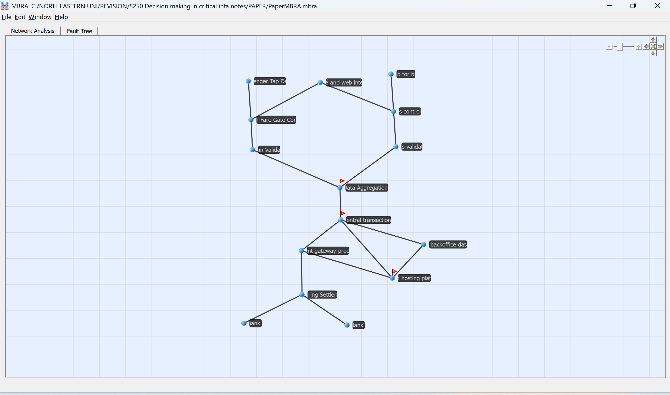
Fig1: MBTB AFC 2.0 payment Network graph as plotted in MBRA.
3.2] Key Nodes and Subsystems for Risk Modeling
Within the AFC 2.0 ecosystem, several nodes and subsystems play a disproportionately critical role in maintaining the reliability and security of the entire network. Among these, the Central Transaction Server (CTS) is the most vital element, as it is responsible for processing fare validations, reconciling travel histories, segregating account data, and routing payment information to the appropriate financial entities. Because it serves as the authoritative source for transaction integrity, any compromise of this node such as data tampering, unauthorized access, or service disruption—has the potential to cascade across the entire system, affecting both operational continuity and revenue flows. Another similar critical subsystem is formed by the pathway linking Local Aggregation Center (LACs) which has data collected from various validators and cloud or external payment gateway. This communications path must be hardened by implementation of authentication, and being resilient as interruptions within these will result in corruption of transaction batches, delayed payments and undermined data consistency. These high-impact nodes act as single points of failure within the AFC 2.0 architecture, where disruptions can trigger widespread cascading effects across financial settlement systems, customer accounts, and the broader transportation network.
3.3] Mapping the Payment-Flow Network
The AFC 2.0 system operates through streamlined, multi-layered data and payment flow. When a customer taps a card or mobile device at a fare gate, the front-end device transmits the transaction record such as the credentials regarding the customer as well as the payment record done to the nearest Local Aggregation Center (LAC). The LAC temporarily stores and performs account lookup, fare calculation, validation, and fraud checks the customer records before forwarding them to the Central Transaction Server (CTS). Once CTS approves the transaction, updating of the customer’s account balance and logs are updated into the system’s operational database as well as the cloud server as backup. Payment-related data is securely routed from CTS to the Cloud Backend and then forwarded to the Payment Gateway Processor or banking partner for settlement. Finally, real time synchronization is done via the data updated in LACs and CTS and finally the fare collection systems. This end-to-end process ensures accurate fare validation, consistent data integrity, and seamless coordination across both transportation and financial subsystems.
4] Threat Landscape and Potential Cyberattacks
A very recent example of cyberattack on Maryland Transit Administration (MTA) happened on September 29, 2025. Reportedly MTA was under cyberattack which hampered real-time information communication and resulted in data loss. The reason can be phishing or usage of obsolete software. Similarly, MBTA fare-payment network has many attacks to deal with because of its vastness. Firstly, the fare collection servers, kiosks, and station controllers face the risk of malware or ransomware attacks. The above-mentioned components along with others like users facing API, station WAN links, gateways to payment processors face the risk of replay, DDoS and MITM attacks. The MBTA systems can also be disrupted if an attack takes place on concurrent payment processors or bank interfaces connected to the systems. Software vulnerabilities like SQLi can be used on Web APIs, websites, and mobile apps. Attacks can also arise from a network point of view if operational and payment network segmentation is not done properly. Attackers can also embed malicious codes in fare collection system to allow passengers to evade paying the fare as well as allowing threat actors to harvest personal data through the cards used by passengers.
4.1] Threats to AFC 2.0 Network Components
In critical infrastructure of transportation an cyberattack is aimed at bringing the system to a halt and creating chaos rather than aiming at gaining ransom. The MBTA AFC 2.0 network is also vulnerable at many points which facilitate entry points for malwares, and attacks like redirection and spoofing. Because of usage of modern technology critical nodes in the network like the Data aggregation center, Central transaction systems and Cloud infrastructure as well as the database used for managing transactions are susceptible to cyberattacks. For example, Fare collection systems deployed at every station and vehicle sentry point can be targeted for Point-of-Sale Malware, Rouge Firmware updates and API manipulation and DDoS on ticket servers. Another critical sector in the studied network is the payment gateway and clearance node for banks. The outflowing transactions can be hijacked and redirected, or providing wrong financial output predictions leading to under/over settling.
The kiosks used for ticketing giving on the stations, the payment booths on vehicles are connected to central server via network, Wi-Fi, routers and SCADA devices which can be exploited in many ways. The threat actors can initiate a cascading effect by holding these machines ransom, or by tampering SCADA devices disrupting the operational flow of the network. The train miscalculations can take place if threat attackers decided to perform GPS spoofing and introduce rouge access points to give commands to various operational technology. The same network can be penetrated via Mobile App ecosystem by reverse engineering the application to create botnets and data exfiltration.
4.2] Cascading Impact of targeted attacks on Node
The attack scenarios can be specifically targeted for certain devices in the network. There are many hotspots in the network which can lead to disruption of the entire network if compromised. The targeted attacks can be solely dedicated to cloud computing. The credential threat is one of the few most common targeted attacks in cloud computing. Here the cloud architecture is connected to critical nodes and depend upon the cloud service used and the cloud platform used like Azure. AWS the attack can be formulated to gain credentials. Once the credentials are gained the attacker might change the rules and regulations for analyzing the payments and consequently compromise the database. Attackers can also target the network related to cloud and through third party gain escalated privileges on cloud platform. This can also lead to compromise of entire systems as falsified data can be sent in via legitimate and trusted cloud source. Another targeted attack might take place on the web APIs. The attack might compromise the web application and divert the entire payment to a fraudulent account instead of the tap machine creating confusion among users. The website can be defaced motivated by any political agenda which can initiate a new controversy in the city. A targeted MITM attack might be possible on critical links. Threat attackers can introduce duplicate servers in the network externally, creating confusion for the packets. This will fool the packets, and modified data can be exchanged in networks by the attackers or sensitive information of customers can be harvested.
5] Network Characterization
5.1] Node List and Adjacency Structure and Spectral Radius
- Node List:
Node List | Node Designation
N1 | Train Tap Device
N2 | Bus Tap Device
N3 | Mobile or Web Interface
N4 | Fare Gate Device for Bus
N5 | Fare Gate Device for Train
N6 | Bus Validator Device
N7 | Train Validator Device
N8 | Local Data Aggregations Center
N9 | Central Transaction Server
N10 | Database Server
N11 | Payment Gateway Processors
N12 | Cloud Hosting Platform
N13 | Clearing Settlement Interface
N14 | Bank 1
N15 | Bank 2

- Adjacency matrix: A mathematical representation of the network to show the connections for the nodes.

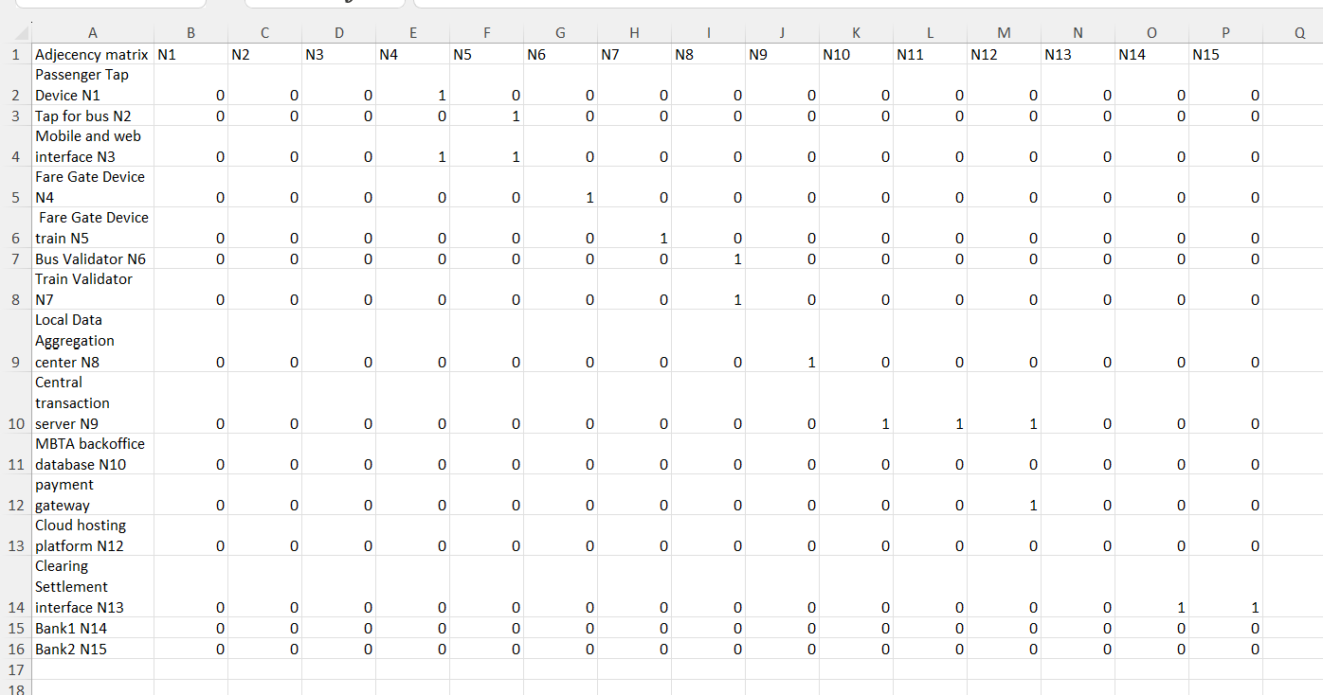
The python program made use of the adjacency matrix further for calculation of spectral radius.
- Total Degree for each node:
Node N1: total degree = 2 | Node N2: total degree = 2 | Node N3: total degree = 4
Node N4: total degree = 6 | Node N5: total degree = 6 | Node N6: total degree = 4
Node N7: total degree = 4 | Node N8: total degree = 6 | Node N9: total degree = 7
Node N10: total degree = 5 | Node N11: total degree = 5 | Node N12: total degree = 6
Node N13: total degree = 5 | Node N14: total degree = 2 | Node N15: total degree = 2
- Mean Degree: The mean Degree for the network is: 4.4
- Eigenvalues of connection matrix C =
[ 2.6827+0.j 2.1374+0.j -2.2527+0.j 1.185 +0.j
-0. +0.j -0.6336+0.3556j -0.6336-0.3556j -1. +0.j
-1.4852+0.j 1.4142+0.j 1.4142+0.j -1.4142+0.j
-1.4142+0.j -0. +0.j 0. +0.j ]
The Eigen value is the largest absolute value for the matrix used to calculate spectral radius for the network. The Eigen value of the node can be thought of as a numerical representation of the influence of the node on the network. The spectral radius is the largest absolute eigen vector found for the matrix.
- The spectral radius: [ 2.6827 +0.j ]
The spectral radius is used as an indicator of whether a network is connected. Even though the attack surface is growing, a higher vulnerability is correlated with a larger spectral radius.
5.2] Centrality Analysis (Degree / Betweenness)
- Degree Centrality:
N1: 0.1429 | N2: 0.1429 | N3: 0.2857 | N4: 0.4286 | N5: 0.4286 | N6: 0.2857
N7: 0.2857 | N8: 0.4286 | N9:0 .5 | N10: 0.3571 | N11: 0.3571 | N12:0.4286
N13: 0.3571 | N14: 0.1429 | N15: 0.1429
Degree centrality mainly tells us about the connections of the nodes. The more connections the higher the degree centrality for the nodes. Higer degree centrality further leads to propagation of threats in the network.
- Betweenness Centrality:

N1: 0.0 | N2: 0.0 | N3: 0.0659 | N4: 0.1841 | N5: 0.1841 | N6:0.1896
N7: 0.1896 | N8: 0.456 | N9: 0.3984 | N10: 0.0989 | N11: 0.1813 | N12:0.1016
N13: 0.1429 | N14: 0.0 | N15: 0.0
Betweenness Specific that perhaps the network is oriented, the concept of centrality corresponds to the quantity of times a given node appears on the path that offers the shortest distance between two other nodes.
5.3 Robustness, and Blocking Nodes and Resilience Line
- Link Robustness:
The link robustness refers to connections which can be removed from the network without resulting in any network disintegration into collection of fragments.
R = 1-(2/mean degree)
E= number of actual links
N = number of nodes
R = 0.11
- Node robustness:
A node robustness is the measure of how well the network sustains if a certain node is removed form network.
N = 1- (1/spectral radius)
N = 0.6272
- Blocking node:
Blocking nodes are critical nodes in a network when removed disrupts communication between other nodes by breaking connectivity or partitioning the network
B = 1/spectral radius
B = 0.3727

- Resilience Line:
ln(q1) = b + k*y1*p…………………………equation1
ln(q2) = b+ k*y2*p…………………………. equation 2
q1: Expected Loss of node 1
q2: Expected Loss of node 2
y: Node vulnerability measure
p: Spectral radius
b: Intercept of the Critical Vulnerability Line
k: Slope of the Critical Vulnerability Line
- Calculation of Critical Vulnerability:
 | q | Log(q) | y1-y2 | p(y1-y2) | k | b | Critical Vulnerability
For V=20% | 1.65 | 0.500775 | 0.15 | 0.402405 | 1.39822 | -1.37473 | 0.9
For V=90% | 0.94 | -0.06188 | - | - | - | - | 0.1

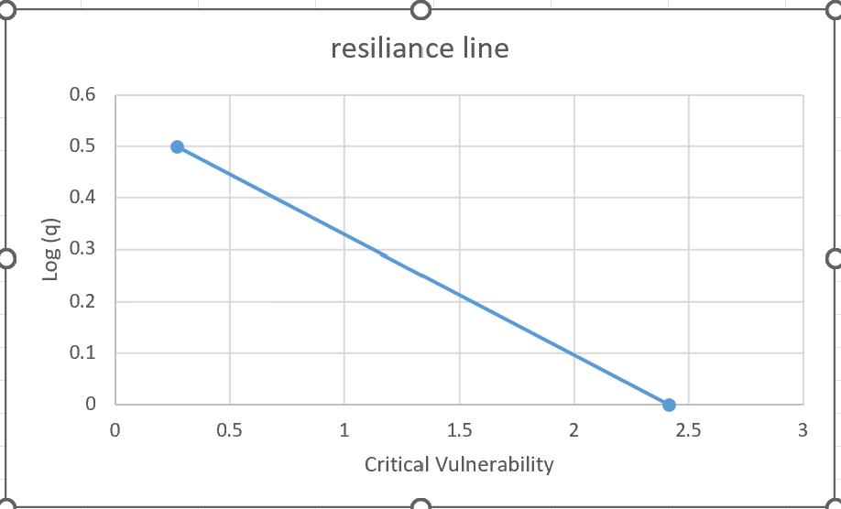
Fig2: Resilience Line [X axis: Log(q) and Y axis: Critical Vulnerability]

6] MBRA Risk Assessment Framework
6.1] Methodology and Budgeting Assumptions
Because no publicly available cybersecurity investment data exists for MBTA AFC 2.0, the study assumes a defensible budget allocation for MBRA simulation. It was assumed that the project would at least spend 5 million for security or hardening the nodes as well as the connecting links every year. The project started in 2018, therefore, in 2025 the budget will be 40 million. Out of the 5 million allocated every year, 60% were assumed to be allocated to prevention costs and 40% to response costs. Hence the total expenditure for the 8 years will be 24 million for prevention costs and 16 million for response costs.
The consequence was divided into assumed hierarchical data with 5 dimensions consisting of Very high, High, Medium, Low and Very Low. Depending upon the criticality of the nodes and number of nodes it is connected to the consequences that were distributed among devices. Here any kind of loss will be procured in dollars and human lives. Hence for the calculation of the MBRA tool the consequence was considered budget or expenditure done to mitigate the attack or attacker gain in dollars if the network is successfully compromised. For prevention, cost was allocated from attack point of view considering the attack vector targeted critical nodes such as CTS. Considering the industry standards and policies being implemented for CIKR for such a critical node, minimum devices requirement by attackers and to build and various modifications required, the budget was kept as 10 million.
For the initial simplicity of calculations, the threat has been assumed to be 100% and vulnerability distribution was the variable factor for the calculations. Hence keeping the vulnerability as 90% once and 10% next the network was being observed for changes. For the links, prevention cost and response cost are kept same through each connection and considered in the category very low. But the consequence of compromising that link depends upon the node’s connections. Hence if compromised, the highest consequence among connected nodes is given to that link.
6.2] Hazard categories and dependencies
The system of critical nodes was decomposed into network considering the payment flow for the AFC 2.0. For this study the hazards were categorized into cyber hazards (malware injection, API compromise, data manipulation, denial-of-service), physical hazards (device tampering, vandalism), operational hazards (software misconfiguration, communication link failure), and third-party hazards (cloud outage or payment processor downtime). Dependencies were mapped by identifying how each subsystem relies on upstream components, for example data aggregation center depends upon the data gathered via tap machines from each vehicle in data validators. The CTS depends upon LAC and cloud and payment settling server depends upon CTS. The impact pathways were modelled by analyzing how a disruption at a single node can have a cascading impact on rest of the network. For example, CTS outage can spread a system wide fare validation failure compromising the cloud, central database as well as the payment settlement server.
6.3] Example scenarios of adversarial Random attacks
To give an example for how a cyber-attack may propagate through the network let’s consider the following scenario: The initial compromise can happen at the edge layer than means the validator node. The attacker can use a rogue NFC device to inject malware in the tap devices located on vehicles. The attacker will target this node and link as this is the node which is easily accessible to hackers as well as this is the node which uses wireless or cellular backhaul to connect with the validators. Also, these nodes have limited physical protection and tampering with these devices can be done easily as limited security protocols are implemented allowing the hacker to transmit spoofing tap events faster than real passengers to create artificial ghost passengers with fraudulent transactions. Once the malware is injected the malformed data packets will be stored in local data aggregation center. If the input validation is weak for the LAC the malformed data packets will be allowed to pass ahead to the network. This propagation may also occur if the network segmentation implemented is weak between validators and LAC. Hence the malicious packets are accepted and batched along with legitimate events and LAC assumes the validator is trusted and forwards all the data to the Central transaction server.
The LAC to CTS as we know is a bottleneck in the network. Compromise of this critical link allows hackers to propagate to either direction creating havoc throughout the system. Once the malformed packets reach the most critical node of the system that is the central transaction sever, it will trigger a logic bug in the CTS validation engine. This may target the integer flow in the fare calculations. This causes CTS to incorrectly track fraudulent taps as valid and the equations change. Once this layer of the systems is compromised, lateral movement in the network can easily be done, and system-wide effect begins. CTS is directly connected to Cloud server, database server and gateway server for financial traction settlement. CTS is designed to synchronize transaction logs with cloud for storage, analytics and mobile app synchronization. The cloud server relates to the central database and hence the misconfiguration in cloud because of the injected data changes the database as well. The injected data can cause unvalidated pass-throughs, corrupt the analytics dataset and pollute the user accounts with false records. Hence the corrupted data now becomes trusted source for the calculations of fare, mobile ticketing service and account management. Once fraudulent data is stored in the cloud attacker can move to mobile app services. These services are already handled by cloud and are directly connected to tap devices on the vehicles. The attackers may exploit internet-facing websites, token reuse vulnerabilities to update user balances with corrupted values in cloud servers, change transaction logs and fare rules and amount. As the data in cloud server is already compromised the changed data through web services is accepted and trusted and considered legitimate by the system. This opens a secondary coordinated attack scenario from threat attackers’ point of view. Finally, CTS send the data to settlement packets to the payment gateway processor. Because the links between the CTS and gateway are highly secured, the attacker can’t breach the gateway itself, but the malformed corrupted data can pass through resulting in incorrect settlement requests, fraudulent changes, reconciliation mismatches and banking disputes. Even though the gateway is secure, its inputs are poisoned. This is known as a trusted-source attack.
6.4] Cascading Impacts on other nodes
There will be cascading effects of such attacks rendering many systems unavailable or bringing them to a halt. Technically such type of attack can create system-wide fare validator error. The registration of fake and duplicate taps in the system also must be searched thoroughly throughout the systema and erased. The effects can result in incorrect user balances because of possible multiple taps. Mobile apps will also be hampered resulting in mobile ticketing failure. Main technical errors take place on the cloud server where database will be corrected and must be restored as soon as possible. Finally, settlement disputes may arise cause of the corrupted data and must be resolved immediately. Other impacts like operational where riders cannot board due to incorrect card status, customers services call volume spikes, temporary shutdown needed validation of systems, manual collection of fees may take place for days or weeks. The attack will result in financial impacts resulting in revenue leakage, chargeback penalties, loss of passenger trust and regulatory non-compliance (PIC-DSS).
7] Findings from the cascading model:
7.1] Budget Sensitivity and Risk Reduction Insights
Referring to the model designed in using the MBRA tool and the data received by varying the vulnerability factor we can relate the actual results with the above scenario. We can deduct from the MBRA tool by observing the initial risk column in the data set that there are 10 critical nodes and links combined which if under attack can result in catastrophic failure of the entire system. These nodes and links have 90% of initial risk which tells us that these are high risk factor nodes. The critical nodes are as follows CTS, Payment gateway, Cloud Hosting platform. The prevention budget discussed earlier was distributed for these nodes considering high risk factors but in MBRA we can see only 15% for the critical node of Central transaction server was reduced. There was a massive change in risk reduction observed when keeping the response cost, prevention cost was increased. And we get a result of 100% reduction in risk when the expenditure reaches 50 million for prevention cost. Similar results were observed for another critical node of Cloud platform. The estimated prevention and response cost required to fully mitigate the risk as calculated by MBRA tools is 60 million for prevention cost. Like the CTS for cloud node as well the prevention cost played a critical function in reduction of risk rather than response cost. However, for the payment gateway node the risk reduction takes place very slowly and huge number of budgets are required to bring the risk reduction range at an acceptable number. Unlike the other nodes increasing in prevention budget doesn’t have much effect nor does increase in response budget. Hence payment gateway should be hardened from time to time and must be updated from technical as well as compliance point of view.
However, for a critical link linking critical node CTS with data aggregation server, the risk reduction takes place only when both the prevention and response costs are increased correspondingly. The risk reduction also takes place very slowly compared to nodes risk reduction. With current model’s various budget sets the link gives maximum reduction at prevention and response cost being 35 each and 16% risk reduced. Another critical link is the link joining the CTS with cloud data server. As seen in the earlier link, risk reduction takes place very slowly hence securing the links happens to be more critical than securing the nodes. Especially the critical links joining one or more critical node.
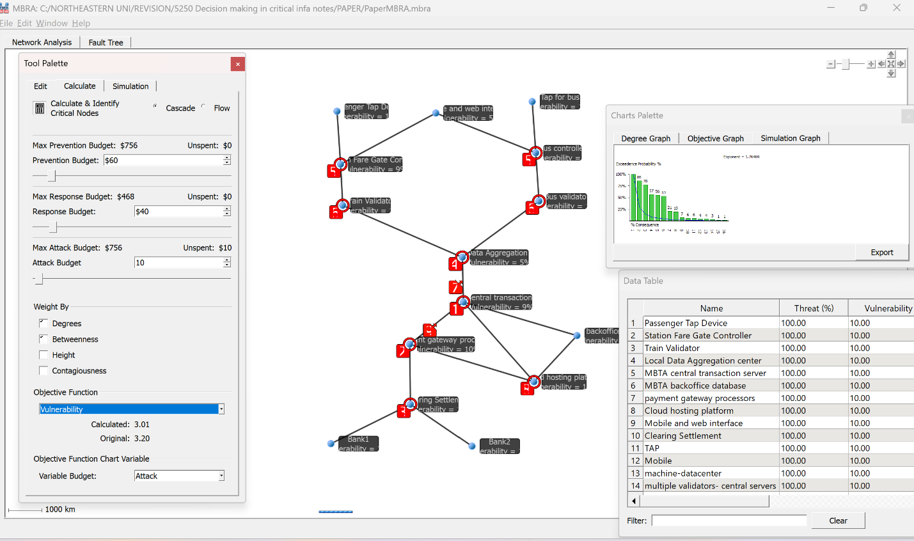
Fig3: AFC2.0 Network graph with 90% Vulnerability

7.2] Fault Tree Analysis Results
The fault tree analysis using the MBRA tool initially the main 3 nodes which are the Cloud hosting platform, the Central Transaction Server and the Data aggregation center were analyzed using only two scenarios. The scenarios were taken only for malware and DDOS attack happening non simultaneously. Hence either the systems will face a DDOS attack or a malware injection attack. Also, it was considered that either of the two attacks will not occur simultaneously on every system. Hence, the network will be under stress only one device at a time. The results shown were that even if only one device is put under stress the overall risk reduced was only 50%. The maximum risk was reduced for data aggregation centers and not even 50% was reduced for cloud hosting and central data servers. For the same combination the vulnerability reduction also occurred for 50% throughout the selected nodes. However, if both attacks simultaneously occur in the network the risk reduction components remain the same, but the vulnerability is reduced is only 1.25%
Second scenario was taken as per the network and AND factor was introduced everywhere that means as the malware progress form data validator considering the data validator as the initial vulnerable machine. The AND progression shows that as malware progresses every node gets either DDOS and malware injected. Here, during the fault tree analysis, the output risk reduction happened by 42% and 25% reduction took place in vulnerable devices. This was considered at a moderate to low budget of 40 million. As we go above the budget, let’s say 80 or 100 million we can observe that the risk reduction takes place at a slower pace, but the vulnerability reduction shows drastic change from 25% to 9%. During both the scenarios the maximum risk was reduced from validators or the initial compromise devices. This might happen as the database, CTS and cloud fall under heavy policies and are generally considered secure in nature compared to peripheral devices like tap devices and data validators.
The results tell us about the potential failure in the network as well as the CIKR network. The system is vulnerable from various angles as the threat actor has multiple sources to enter the network. The network itself has some structural critical nodes like CTS and cloud etc. These nodes possess high criticality rating along with high betweenness centrality and degree centrality. Nodes with high betweenness and degree centrality are the nodes which are interdependent with various domains. Another essential CIKR sectors of electricity and finance are linked to this network via central nodes which increases the criticality of the nodes and links. The results also showed how the network starts to degrade linearly till it reaches the central transaction server and an exponential decline takes place after the compromise of CTS. We also derived where the acceleration of the degradation process takes place and which components to secure to avoid such scenarios.
7.3] Non-Intuitive Insights from the Model
As we have seen in the fault tree analysis using the MBRA tool, maximum risk is reduced at validators. Hence the risk is high at validators rather than the main components of the networks. The main components of the network are the CTS, database, cloud and data aggregation center. Therefore, we can say that the network is at risk mainly because of the peripheral devices rather than the main components. As the peripheral devices like tap devices and data validators are using much more technology like SCADA or are more exposed and are widely spread among network, these are the most vulnerable devices in the system and network. Also, the number of devices and the environment in which the devices are, matter. CTS and cloud are networked in industry secure manner considering all the policies and compliance related rules. The same should be applied to the peripheral devices and security should be enhanced for these devices.
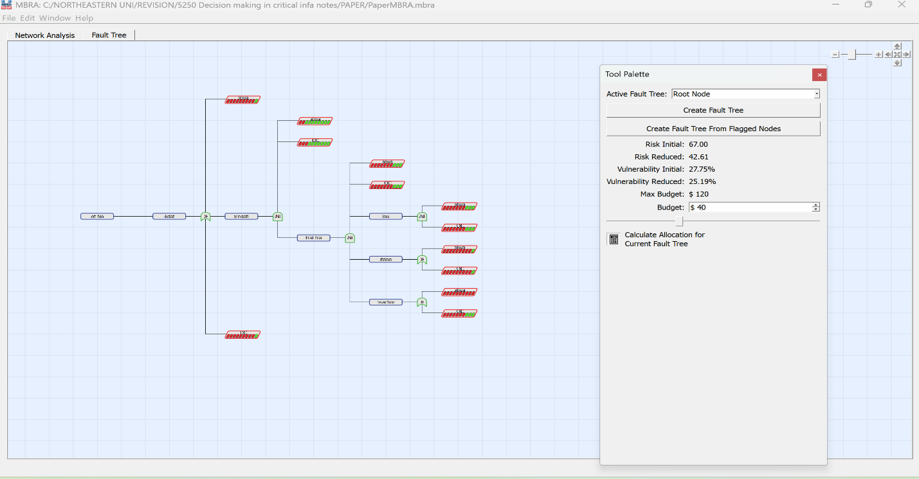
Fig4: Fault tree Analysis of AFC2.0 Network
8] Discussion
8.1] Required Budget for Mitigation and Resilience
An estimate of required budget for risk mitigation can be derived considering the security and resilience requirements for AFC 2.0 and the scale of the network and maturity of existing security controls. Based on the risk assessments and analysis done earlier the mitigation budget can also be divided into technical security upgrades, operational process improvement and resilience engineering.
- The key cost requirements for Technical Security enhancements arise from security firmware updates for validators, gates and kiosks. Depending upon the device the cost may vary from $200-$400. Another cost of per device per year comprising of $40-$80 will be required for endpoint protection and monitoring agents. Implementation of zero trust architecture comprising updated firewalls, network reconfiguration into segments etc, will have a significant contribution of around $150 k per year for it to implement for full AFC 2.0. Also considering the continuous monitoring and SIEM integration of peripheral devices and encryption upgrades for fare media and backend APIs will add another $300 -$500k yearly.
- Second contributing factor is the operational security controls comprising various factors such as workforce upskilling and certifications which will depend upon number of employees and annually. Second the incidence response playbook development specifically for AFC 2.0 contributing around $25-$80 k annually depending upon the scenarios considered and executed in the network. Lastly, the supply-chain auding and hardware vendors contracted to improve the security depends upon the size of the contracts and devices considered. Another factor of regular penetration tests on network and the critical devices will contribute to a significant amount nearly $150-$180 yearly depending upon which nodes and links are considered.
- Lastly, the resilience engineering and redundancy category reduces cascading probabilities, especially among nodes having high betweenness centrality or spectral influence, improving the resilience of the network. These costs are high upfront cost but once installed reduce a significant amount of risk and contribute to long-term saving s by reducing downtime, and disruption risk. Considering the criticality of databases and their connectivity with other critical nodes such as CTS and cloud, a redundant backend server may cost up to $250k to $1.2M depending upon the expected throughput. Another cost of around $150-$300k depending upon architecture is to be spent on load balancers and replications setups for AFC 2.0 subsystems. Updated systems such as automated backups and backup communications links for stations clusters might contribute another $100k to the overall resilience cost.
Concluding with long term financial outlook or benefits for AFC 2.0 with expenditure for resilience improvements include:
- Reduced downtime and costs during outages
- Lower fraud-related revenue losses
- Fewer emergency repair contracts
- Extended lifecycle of AFC infrastructure
- Better regulatory and insurance compliance.
The improvement of resilience is moderate as we have seen through the MBRA statistics. The network shows moderate resilience to random failures but potential fragility to targeted attacks. The blocking nodes data derived confirms that removal of any single high-centrality node can cause complete outage rendering significantly reduced connectivity in the network. Overall, resilience depends mostly upon how hardened and redundant the high value nodes such as Central Transaction server, Local Data aggregation center and links connecting them are.
9] Discussion of Cyber Work Force preparation and the potential role of NICC, NCICC
Readiness and maturity of supporting cybersecurity workforce plays a very critical role along with technology requirement for the AFC 2.0. As threats are becoming increasingly sophisticated and adversaries are increasingly making use of newer TTPS to target transportation and payment systems, enhanced workforce capabilities are becoming essential for reducing probability of downtime and response times, improving detection capabilities and accuracy and enabling better coordination during incidents. His is where national level coordination bodies such as National Infrastructure Coordination Integration Center (NICC) and National Cybersecurity and Communications Integration Center (NCCIC) play a very important role.
The AFC 2.0 does depend upon multiple domain integrating payment processing, industrial control components, cloud and backend services, yet workforce reediness and bridging the skill gaps is a need for the hour. NICC and NCCIC can mend these existing gaps by providing
- Exposure to cyber-physical security to workers
- Proving sufficient hands-on training in fare systems, hardware and firmware security to on ground workforce.
- Realtime monitoring and incident triage skills
- Maximum exposure to threat intelligence and cyber security situational awareness to workflows.
Strategic support is provided by NICC as its role becomes critical when transit infrastructure faces cyberattack from cross sector having cascading impacts. The NICC primarily supports coordination and information flow across critical infrastructure helps in the strategic support. The support is provided as follows:
- Coordinating communication between critical CIKR sectors like transportation, energy, and communication sectors.
- Incident response management programs encompassing integrated situational awareness platforms for faster resilience.
- Facilitating national level exercises including transit fare systems and their dependencies.
- Faster sharing of interdependency risk insights aligning with MBRA model used in this study.
Similarly, NICCIC is the heart of operational cybersecurity and provides technical assistance, incident response and real-time threat intelligence. NCCIC supports cyber security workforce preparation through:
- Providing operational threat intelligence alerts and real time feeds relevant to transportation and CPS systems.
- Support during Malware analysis and during crisis if any peripheral device is compromised.
- Technical assistance is provided all the time during major cyber incidences.
- Hands-on training, workshops and tabletop exercises aimed at building technically sound resilience workforce.
- NCCIC can also provide best practices and security advisories which are specifically tailored to embedded devices, APIs, and cloud systems.

10. Mitigation and Resilience Strategies
10.1] Technical controls
To implement mitigation strategies for this network we need to consider the technical operation as well as the attacks arising from supporting industries and what policies are implemented for the network.
- The network suffers from technical controls at the smaller devices at the entry of data. The nodes and the links used for initializing of the data stream must be hardened. The tap machines should be redesigned, and the most used cards should be encrypted inside the machines. Collaborating with the banks the systems should be redesigned to get unique IDs for the cards which can only be validated by the tap machines. In this manner we can at least only allow legitimate traffic inside network.
- The validators can have additional hardcoded encryption control which can verify the inputs in the tap machines. A token system should be implemented by the designer where in a temporary unique token will be generated for a user till the data reaches the CTS and is verified as not tampered during transit.
- Crypto key storage can be used for encrypting the data during transit added with the unique token of user as salts to verify as well as trace back the user if any suspicious activity is detected later. As we all know the CTS, cloud and transaction server will be under extreme secure controls like multifactor authentication (MFA), zero trust architecture. The need to control the arising data request and quality should be dealt with.
- The central data aggregator can use verification method by segregating the routes in various regions. The regions can have some specific data controls which can act as a third way to control the data input. These controls can validate the user’s legitimacy as well as prevent DDOS attacks if there is a spike in the sudden transaction request. These regions can also act as micro segmentations for the backend database as well the CTS. This micro segmentation in network can help reduce the damage by limiting the spread of the threats or malware in the network. Also, from investigation point of view it will be easier to analyses ethe spikes and segregate the regions accordingly to reduce the search dimensions.
- Special care must be taken for the API interface as they are publicly available and have direct entry to the critical cloud systems implemented. The APIs can have authentication controls and authorization controls. Recently OAuth 2.1 and OpenID connect are strong mechanisms to implement for authentication. API must have rate limiting factors implemented as they help defend against DDOS attacks. The endpoint including the kiosks at stations, tap devices and the validators should be implanted with detection and mitigation systems to detect anomalies at early stage.
- Logging the data at every stage is also a critical security implementation. End to end encryption of cards, logging details and user information including the data transmission phase can be stored in secure blackchin immutable ledgers. Allocating only user roles to the devices to the central aggregation center can also limit the lateral movement of hackers.

10.2] Operational controls
The devices already existing will be using technologies like IDS/IPS and firewalls for security protection. But these devices mainly monitor network security.
The IDS/IPS devices can detect the packets being sent and resist against some known threat signatures. The problem is that these devices are also included in the system of network. Hence attacks can also arise from security devices. Keeping them updated and resistant to newer threats is the crucial part of defending the network. The devices used should also be updated to detect card cloning and other card related attack vectors.
- A security check could be imbibed in the defending devices themselves to monitor the health of the devices like tap devices and gates.
- If there is gate malfunction these devices should be capable of that abuse and generate alerts and may be designed to suggest segregation of load and act as a preload balancer.
- Strict patch management and regular check done by field technicians to tap devices and aggregators can reveal if some malwares were injected or if any advanced persistent threats were embedded in the network.
- Regular red teaming exercises must be done on critical nodes like CTS and cloud hardening the already existing rules and regulations. Any firmware updates or device replacement should be done under strict observation with requirement f software Bill of Materials (SBOM) being thoroughly reviewed by experts.
- To tackle logical attacks like malware and DoS segmented payment network can be implemented along with EDR tools and application whitelisting. Load balancers and rate limiting software can be implemented to protect against DDoS attacks. Encrypted communication using TLS/E2E, multifactor automated token authentication, certificate management as well as network monitoring can be implemented for securing network traffic and threats. Message sequence, nonce and NGF to be installed server-side to prevent relay attacks. Specifically for card vulnerabilities EMV level cryptographic authentication can be implemented preventing cloning attacks. Strict PCI-DSS compliance, least privilege access control implementation along with regular audits and penetration testing can provide insights about anomalies and timely mitigation can take place.
10.3] Governance and Compliance Recommendations
- The network will already be using industry recommendations for policies and governance like for cloud FFIEC Cloud Computing Guidelines for federal institutions, especially for risk management for cloud outsourcing in banks and credit unions. Implementation of FS-ISAC Cloud Security Practices for financial services information sharing and analysis center, guiding institutions in securing cloud environments. [25] 26]
- For contactless payment methods or card payments the PCI DSS ensures proper security patch management, network segmentation, encryption, and access control is implemented.
Along with the above-mentioned, the industry also recommends ISO/IEC 27001 for internation standard security management and NIST SP800-53 and SP 800-171 for establishing baseline security controls for cloud, data bases and transaction systems.[27] [28] [29]
Along with securing the critical databases and cloud infrastructure, the systems should also take into consideration the peripheral devices for security. The propagation of malware starts not targeting high value targets like CTS, but less secure devices installed everywhere.
- A standardized industry policy and governance recommendations should be found and implemented for the devices which are non-critical but help threat attackers to initiate their attacks. These devices also use a range of different technologies compared to traditional databases and cloud infrastructures. Hence a combination of multiple standards will have to be enforced and combined to get collective defense from all the threat vectors and technologies.
11] ROI and Funding Opportunities
The Return on investments (ROI) in cybersecurity for MBRA AFC 2.0, it’s better to present a theoretical ROI framework considering the data which is available publicly.
Under the baseline scenario where no mitigation strategies were implemented the expected annual loss can be distributed among the following parameters. To express monetary-equivalent units one can refer to fraud, system downtime, settlement disputes, revenue leakages. Considering the required prevention and response cost, estimated earlier to be 40 million, can be simulated considering prevention costs from hardening requirements, encryption, network segmentation and response cost from incident detection, failover mechanisms, rapid recovery to yield the models expected reduction in the overall risk. Hence, we can calculate the ROI based upon the difference between the baseline and mitigated loss to yield the avoided loss. Hence, if we consider the total cost of the prevention and response according to the MBRA tool, the cost might increase more than the consideration. Like for nodes the prevention and response cost can go higher than the costs for the links. The 40 million budgets discussed earlier should be less compared to the security requirements for the network. An estimated cost of 100 million for securing the critical nodes of CTS, cloud, settlement server and critical links between data aggregation and CTS, CTS to cloud and database and settlement server and web application to cloud and database will be required. This cost is high but there are various funding options available in the form of grants from central governments which are discussed below.

There are various investment plans from which the MBRA AFC 2.0 can avail the funding. First is the Federal program such as the Transit Security Grant Program (TSGP). The report gives a detailed revie of application details and amount for 2025 fiscal year (FY). The Appendix does mentions MBTA and allocation for the project is $6766,244. There are other funding options available from OPacks for individual teams from 150 million to 600 million. Other resources can be found via Federal Transit Administration department which have details regarding cybersecurity resources for transit agencies. Under the Urbanized Ares formula Grants Programs Guidance (FTA Circular C 9030.2 and Circular 5300.1) [16] the bus services are being granted fund provisions which will be effective from November 11. These funds can be used federal support for security, modernization and IT infrastructure upgrades under prevention budget. Another major update regarding cybersecurity is from Department of Homeland Security (DHS) on August 01, 2025. DHS has announced $100 million to fund strengthening cyber defense. [20] The funding opportunity comprising 91.7 million and 12.1 million, is provided by Cybersecurity and Infrastructure Security Agency (CISA) and Federal Emergency Management Agency (FEMA) [17] under the FY 2025 State and Local Cybersecurity Grant Program (SLCGP) and Tribal Cybersecurity Grant Program (TCHP) respectively. A total of 1 billion was granted for combining 4 years starting from 2023.
12] Limitations and improvements
The AFC 2.0 suffers from fragmented architecture. The integration of multiple vendors like (OpCo LLC, payment gateway, cloud services, fare gates, mobile apps) Each device has its own software and hardware, hence usage of different protocols, firmware version, updates cycles can create opportunity for threat vectors to invade the network. Another limitation is real time visibility. This occurs because of the diversified devices as the scope of adversary entering is too much to concur under single device. The distributed devices will create diverse logs and handling such huge volume of logs is troublesome. Also, huge number of logs create attack surface as well. Probably centralized SIEM with real time streaming form the devices and integrating AI based anomaly detection can help handle this number of logs in real time.
Another huge limitation of the entire gross network is dependance on two different CIKR networks which are electricity and finance. Moreover, critical nodes and links like cloud are directly linked with the external CIKR systems. Failure in any external system can result in cascades into the AFC downtime. For perspective of devices only, the amount of edge devices can themselves work as bots if the attacker is successfully compromised by anyone of them and moves laterally. Hence special security measures like secure booting, hardware attestation, and regular OTA patch distribution can be implemented to secure the peripheral devices. The network as seen in the MBRA, has high single point of failure risk at multiple points. The CTS mainly creates bottlenecks in the system. Probably active redundant transaction servers only activated if in the scenario of attack or it will only create another attack surface and generally redundant servers are often neglected to keep secure.
12. Conclusion and Future Work
Hence, to summarize we have a extremely important CIKR sector tightly coupled with another CIRK structure that is finance sector and is dependent on another CIKR sector that is Electricity. This network is vulnerable for many reasons whether it be the devices used in the periphery or the central security systems like CTS or Cloud or the user-facing web application interfaces. The threat may arise from external tampering or direct attacks on the high-cost devices in the network. These threats can be tackled but can’t fully be mitigated, which we have seen in the fault-tree analysis. The security of the central high value devices is paramount but along with that security of peripheral devices is as important as well.
The network suffers from various threat vectors which can arise directly from cloud base, compromised database as well as compromised critical links like link connecting validators and central transaction server. Not only the critical devices but as seen in the hypothetical scenario in the paper, threats can arise from peripheral devices. Thirdly, the web interfaces introduce another threat vector which can directly compromise the cloud infrastructure and invade the critical nodes if not secured properly. Not only the nodes and the devices links connecting from critical devices have consistently been marked important in the network analysis. Hence data in transition have also to be secured. As seen in the fault tree analysis the risk never gets reduced but vulnerabilities can be reduced as we gain some budget over the years. The results change depending upon the factor considered as the most critical to the network. Hence to decide the expenditure for prevention and response cost and tactics one must decide the most critical factor and allocate the funds accordingly.

References:
[1] Massachusetts Office of the State Auditor, “Audit Report: Massachusetts Bay Transportation Authority—Automated Fare Collection System 2.0 Project,” Boston, MA, 2024. [Online]. Available:
https://www.mass.gov/doc/audit-report-massachusetts-bay-transportation-authority-automated-fare-collection-system-20-project/downloadAccessed: Dec. 2, 2025.
[2] U.S. Federal Highway Administration, “Massachusetts Automated Fare Collection System,” 2025. [Online].Available:https://www.fhwa.dot.gov/ipd/project_profiles/ma_massachusetts_auto_fare_collection_system.aspxAccessed: Dec. 2, 2025.
[3] S. Al-Sultan, M. M. Al-Doori, A. H. Al-Bayatti, and H. Zedan, “Smart Transportation: An Overview of Technologies and Applications,” 2014. [Online]. Available: Smart Transportation: An Overview of TechnologiesandApplicationsAccessed: Dec. 2, 2025.
[4] Massachusetts Bay Transportation Authority (MBTA), “Fare Transformation,” 2025. [Online]. Available: Fare Transformation | Fares Overview | MBTA Accessed: Dec. 2, 2025.
[5] U.S. Federal Highway Administration (FHWA), “Massachusetts Automated Fare Collection Syste–ProjectProfile,”2025.[Online].Available:https://www.fhwa.dot.gov/ipd/project_profiles/ma_massachusetts_auto_fare_collection_system.aspxAccessed: Dec. 2, 2025.
[6] Huntress Labs, “TFL Transport for London Data Breach: What Happened, Impact, and Lessons,” 2024. [Online]. Available: https://www.huntress.com/threat-library/data-breach/tfl-transport-for-london-data-breachAccessed: Dec. 2, 2025.
[7] WISDIAM, “14 Recent Cyber Attacks on the Transport & Logistics Sector,” 2024. [Online]. Available: https://wisdiam.com/publications/recent-cyber-attacks-transport-logistics-sector/Accessed: Dec. 2, 2025.
[8] R. Boholm and M. Milazzo, “Risk Matrix-Based Method for Critical Infrastructure Safety Assessment Taking into Account Interdependencies,” Proceedings, 2018. [Online]. Available: https://www.proquest.com/docview/2057233694Accessed: Dec. 2, 2025.
[9] Northeastern University Library, “Cyber-Physical Systems in Transportation,” 2025. [Online]. Available:https://onesearch.library.northeastern.edu/discovery/fulldisplay?docid=alma9952360743101401
Accessed: Dec. 2, 2025.
[10] Google Cloud, “Protecting Your APIs from OWASP’s Top 10 Security Threats,” 2024. [Online]. Available: https://cloud.google.com/blog/products/identity-security/protecting-your-apis-from-owasps-top-10-security-threatsAccessed: Dec. 2, 2025.
[11] Laing O’Rourke, “MBTA AFC 2.0 Project Overview,” 2025. [Online]. Available: https://www.laing.com/portfolio/mbta-afc-2-0us/Accessed: Dec. 2, 2025.
[12] WT Partnership, “MBTA Automated Fare Collection (AFC) 2.0,” 2025. [Online]. Available: https://wtpartnership.co/experience/mbta-automated-fare-collection-afc-2-0/Accessed: Dec. 2, 2025.
[13] Livable Streets Alliance, “AFC 2.0 Memo – November 2018,” 2018. [Online]. Available: https://d3n8a8pro7vhmx.cloudfront.net/livablestreetsalliance/pages/6146/attachments/original/1546996280/AFC_2.0_Memo_-_November_2018_FINAL.pdfAccessed: Dec. 2, 2025.
[14] Massachusetts State Auditor, “Latest Audit of MBTA Identifies Areas for Improvement Regarding Project Delays and Contract Management,” 2024. [Online]. Available: https://www.mass.gov/news/latest-audit-of-mbta-identifies-areas-for-improvement-regarding-project-delays-contract-management-and-surety-bond-complianceAccessed: Dec. 2, 2025.
[15] TFI Capital, “MBTA Fare Collection System – Project Overview,” 2025. [Online]. Available: https://tficapital.com/project/mbta-fare-collection-system/
Accessed: Dec. 2, 2025.
[16] Federal Emergency Management Agency (FEMA), “FY 2025 Transit Security Grant Program – Appendix B,” 2025. [Online]. Available: https://www.fema.gov/grants/preparedness/transit-security/fy-25-nofo#appendix_bAccessed: Dec. 2, 2025.
[17] Federal Transit Administration (FTA), “Formula Grants for Rural Areas – Program Guidance,” 2025. [Online]. Available: https://www.transit.dot.gov/regulations-and-programs/fta-circulars/formula-grants-rural-areas-program-guidanceAccessed: Dec. 2, 2025.
[18] Federal Transit Administration (FTA), “Urbanized Areas Formula Grant Programs Guidance,” 2025. [Online]. Available: https://www.transit.dot.gov/regulations-and-programs/fta-circulars/urbanized-areas-formula-grant-programs-guidanceAccessed: Dec. 2, 2025.
[19] Federal Transit Administration (FTA), “FTA Circulars,” 2025. [Online]. Available: https://www.transit.dot.gov/regulations-and-programs/fta-circulars/circularsAccessed: Dec. 2, 2025.
[20] Cybersecurity and Infrastructure Security Agency (CISA), “DHS Launches Over $100 Million in Funding to Strengthen Communities’ Cyber Defenses,” 2025. [Online]. Available: https://www.cisa.gov/news-events/news/dhs-launches-over-100-million-funding-strengthen-communities-cyber-defensesAccessed: Dec. 2, 2025.
[21] Cybersecurity and Infrastructure Security Agency (CISA), “State and Local Cybersecurity Grant Program (SLCGP),” 2025. [Online]. Available: https://www.cisa.gov/cybergrants/slcgpAccessed: Dec. 2, 2025.
[22] Federal Emergency Management Agency (FEMA), “State and Local Cybersecurity Grant Program – Funding Allocations,” 2025. [Online]. Available: https://www.fema.gov/grants/preparedness/state-local-cybersecurity-grant-program/funding_allocationsAccessed: Dec. 2, 2025.
[23] Grants.gov, “FY 2025 Cybersecurity Grant Search Result,” 2025. [Online]. Available: https://grants.gov/search-results-detail/360215Accessed: Dec. 2, 2025.
[24] The Hacker News, “Who’s Really Using Your SaaS? Rise of Non-Corporate Accounts,” Nov. 2025. [Online]. Available: https://thehackernews.com/expert-insights/2025/11/whos-really-using-your-saas-rise-of-non.htmlAccessed: Dec. 2, 2025.
[25] FS-ISAC, “Principles for Financial Institutions: Security and Resilience in Cloud Service Environments,”2023.[Online].Available:https://www.fsisac.com/hubfs/Knowledge/Cloud/PrinciplesForFinancialInstitutionsSecurityAndResilienceInCloudServiceEnvironments.pdf Accessed: Dec. 2, 2025.
[26] Federal Financial Institutions Examination Council (FFIEC), “Authentication, Authorization, and Access Management in Cloud Computing,” Apr. 2020. [Online]. Available:
https://www.ffiec.gov/sites/default/files/media/press-releases/2020/2020-april-30-cloud-computing-statement.pdf Accessed: Dec. 2, 2025.
[27] Secureframe, “ISO/IEC 27001: What It Is and How It Works,” 2024. [Online]. Available:
https://secureframe.com/blog/iso-iec-27001Accessed: Dec. 2, 2025.
[28] National Institute of Standards and Technology (NIST), “Security and Privacy Controls for Information Systems and Organizations (SP 800-53 Rev. 5, Draft),” Gaithersburg, MD, 2020. [Online]. Available:https://nvlpubs.nist.gov/nistpubs/SpecialPublications/NIST.SP.800-53r5-draft.pdfAccessed: Dec. 2, 2025.
[29] National Institute of Standards and Technology (NIST), “Protecting Controlled Unclassified Information in Nonfederal Systems and Organizations (SP 800-171 Rev. 3),” Gaithersburg, MD, 2023. [Online].Available:https://nvlpubs.nist.gov/nistpubs/SpecialPublications/NIST.SP.800-171r3.pdf
Accessed: Dec. 2, 2025.

Appendices
A. Network Graphs and Simulation Charts

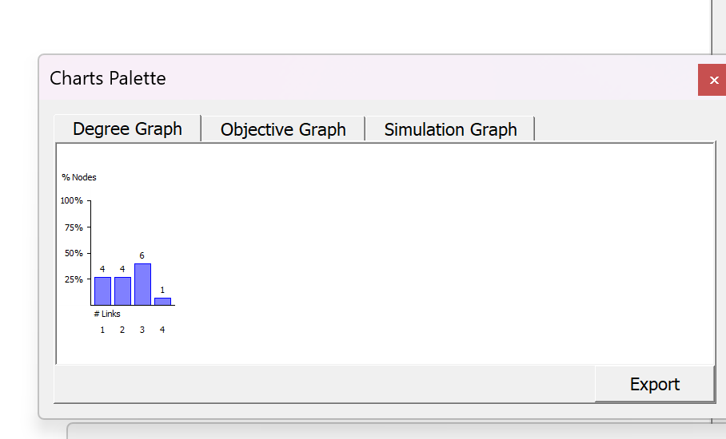
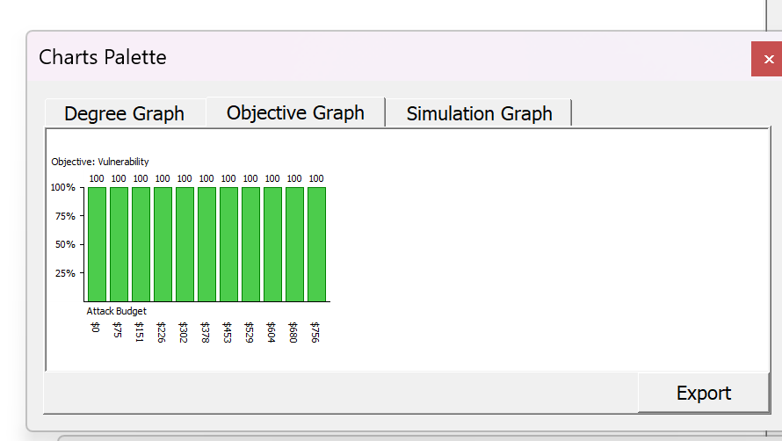
Fig: Degree Graph.

Fig Objective graph
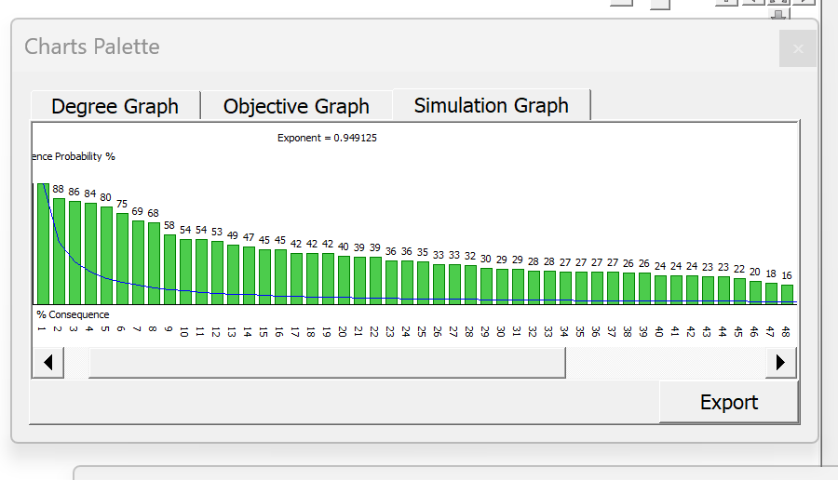Fig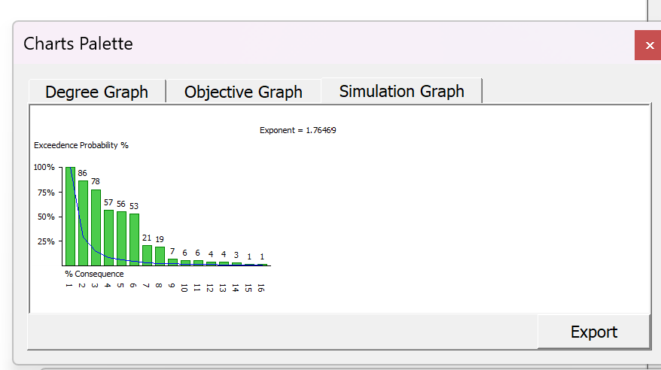
Fig Simulation graph 90%

Fig: Network graph for 10% vulnerability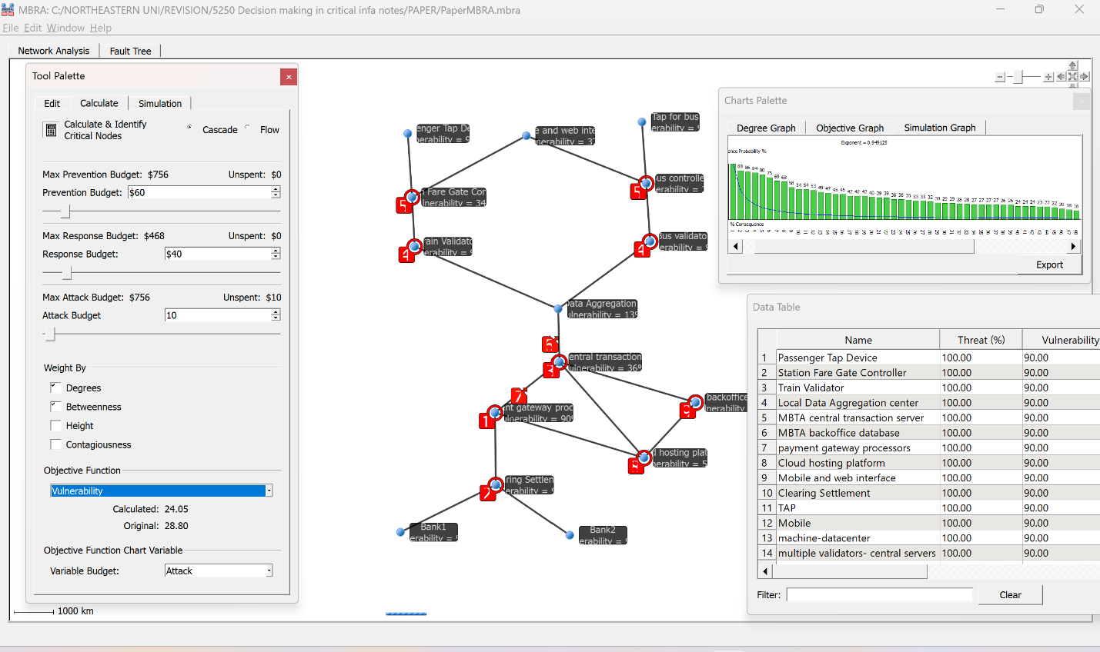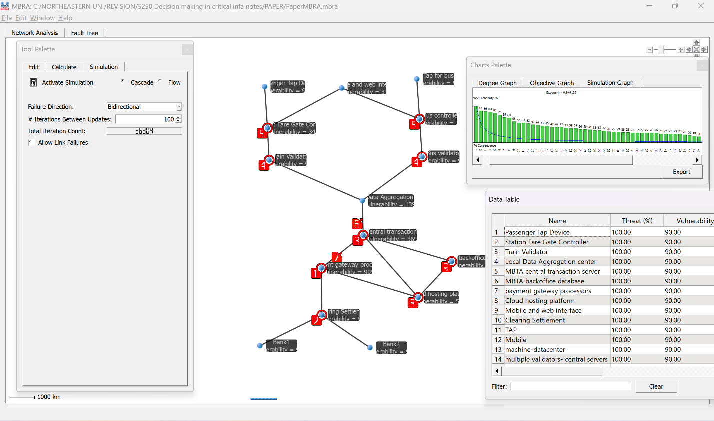
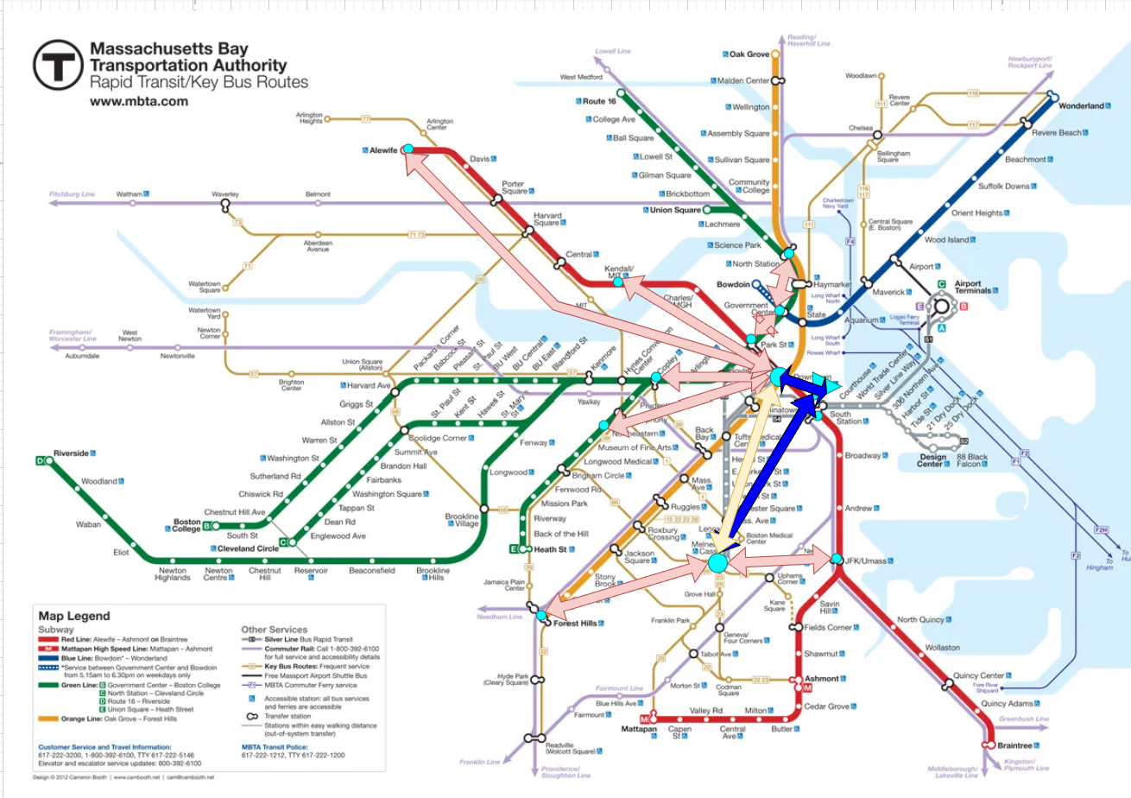

B. Fault-Tree Diagrams

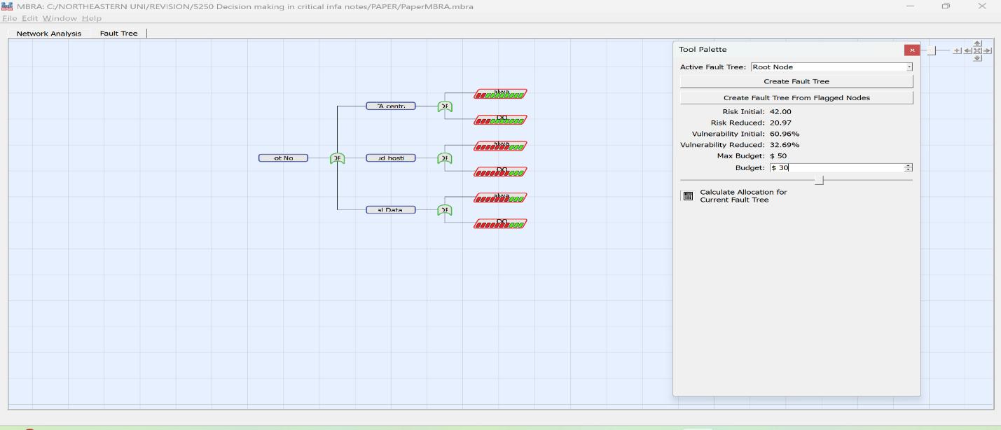



C. Calculation Tables
Solve for $k$and $b$
Subtract the equations:
$$k=\frac{ln⁡(q_{1})-ln⁡(q_{2})}{ρ(γ_{1}-γ_{2})}$$
Compute
$$\ln\left(q_{1}\right)=\ln\left(1.65\right)=0.500$$
$$ln⁡(q_{2})=ln⁡(0.94)=-0.06187540372$$
$$γ_{1}-γ_{2}=0.22$$
$$ρ(γ_{1}-γ_{2})=2.6827×0.22=0.590194$$
So
$$k≈\frac{0.5653138091-(-0.06187540372)}{0.590194}=\frac{0.6271892128}{0.590194}≈1.0626831394.$$
Then
$$b=ln⁡(q_{1})-kγ_{1}ρ≈0.5653138091-1.0626831394×0.5×2.6827≈-0.86011621997.$$

